**University of Michigan – Dearborn**

**CIS 150 – Computer Science 1**

**Lab# 10**

Quan Le

[lmmquan@umich.edu](mailto:lmmquan@umich.edu)

March 23, 2024

**Table Content**

Contents

Question 1 3

Test Cases 3

Source Code 3

Screenshots 4

Question 2 5

Test Cases 5

Source Code 5

Screenshot 6

# Question 1

## Test Cases

|  |  |  |  |  |  |
| --- | --- | --- | --- | --- | --- |
| Test # | Valid / Invalid Data | Description of test | Input Value | Actual Output | Test Pass / Fail |
| 1 | Valid | 5 hey hi Mark hi mark | n = 5  wordVec = {hey, hi, Mark, hi, mark} | hey 1  hi 2  Mark 1  mark 1 | Pass |
| 2 | Valid | 7 english not doing anything enGlish Not not | n = 7  wordVec = { english, not, doing, anything, enGlish, Not, not} | english 1  not 2  doing 1  anything 1  enGlish 1  Not 1 | Pass |
| 3 | Valid | 1 doing | n = 1  wordVec = {doing} | doing 1 | Pass |
| 4 | Valid | 4 for for for for | n = 4  wordVec = {for, for, for, for} | for 4 | Pass |

## Source Code

The source code for this question has been uploaded to Canvas as lab10q1.cpp.

## Screenshots

Test Case #1

Test Case #2

Test Case #3

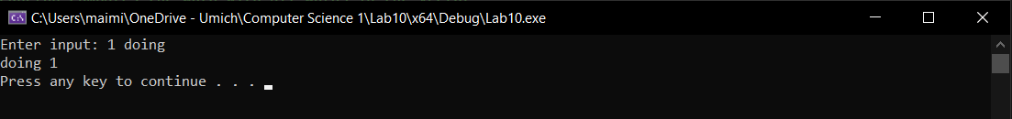

Test Case #4

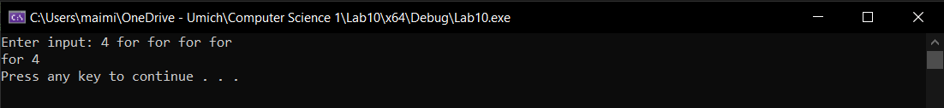

# Question 2

## Test Cases

|  |  |  |  |  |  |
| --- | --- | --- | --- | --- | --- |
| Test # | Valid / Invalid Data | Description of test | Input Value | Actual Output | Test Pass / Fail |
| 1 | Valid | Input file name = test_case1.txt | 32  45  76  21  50 | The number of days with freezing temperature: 2 | Pass |
| 2 | Valid | Input file name = test_case1.txt | Empty | The text file is empty | Pass |
| 3 | Valid | Input file name = test_case1.txt | 80  20  -5  2 | The number of days with freezing temperature: 3 | Pass |
| 4 | Valid | Input file name = test_case.txt | Error file name | Cannot open file test_case.txt | Pass |

## Source Code

The source code for this question has been uploaded to Canvas as lab10q2.cpp.

## Screenshot

Test Case #1

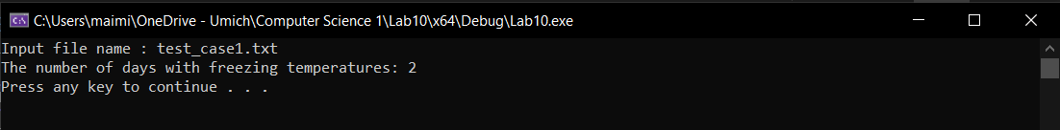

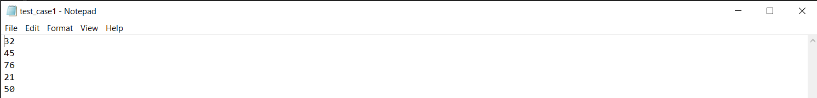

Test Case #2

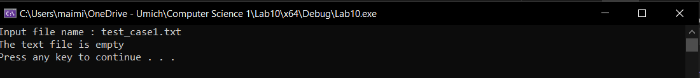



Test Case #3

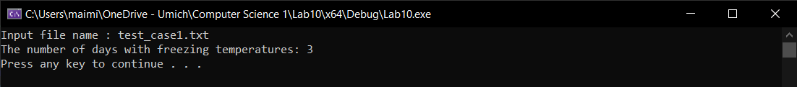

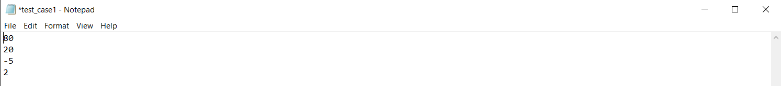

Test Case #4

